**“Farmers Adviser”**

***A***

***Project Report***

*Submitted in partial fulfillment of the requirements for the award of the degree of*

**BACHELOR OF TECHNOLOGY**

*In*

**COMPUTER SCIENCE ENGINEERING**

**with specialization in**

**OIL AND GAS INFORMATICS**

*By*

|  |  |
| --- | --- |
| **Harshit Bisht** | **500068863** |
| **Umang Chaudhary** | **500068770** |
| **Bishal Kumar** | **500069467** |
|  |  |

*under the guidance of*

**Mrs. Poonam Kainthura** Assistant professor (SS) Department of Informatics



**Department of Informatics School of Computer Science**

**UNIVERSITY OF PETROLEUM AND ENERGY STUDIES**

**Bidholi Campus, Dehradun-248007, Uttarakhand March-2021**

**Approved By**

**(Signature) (Signature)**

**Mrs. Poonam Kainthura Dr . TP Singh**

**Project Guide Head of Department**

**ABSTRACT**

India is an agricultural country, and MSP is one of the major aspect in agriculture.

This portal will predict MSP with the help of previous data to help farmers so that they can decide which crop is to be grown.

This system is very convenient to farmers.

**TABLE OF CONTENTS**

**S.No. CONTENTS Page No.**

1. INTRODUCTION **2**
2. OBJECTIVES **3**
3. MODULES **4**
4. DESIGN **5**
5. METHODOLOGY **7**
6. IMPLEMENTATION **8**
7. REFERENCES **10**

# INTRODUCTION

* The farmers necessarily require a timely advice to predict the future crop productivity and an analysis is to be made in order to help the farmers to maximize the crop production in their crops.(Helping them to take wise decisions)
* With the help of Regression algorithms, prediction can be done for farmers to help them decide the suitable crop.

# OBJECTIVES

* To do the analysis and predict the MSP of each crop for upcoming year by applying linear regression.
* To help farmers taking decisions related to their crop yield by applying decision tree

# 

# MODULES

* **MODULE 1:** Calculating the MSP of each crop for 2021 (predicting).
* **MODULE 2:** Deciding the yield type of a crop grown in particular state.
* **MODULE 3:** Designed a portal used for taking input parameters.

# DESIGN

***Activity Diagram:***

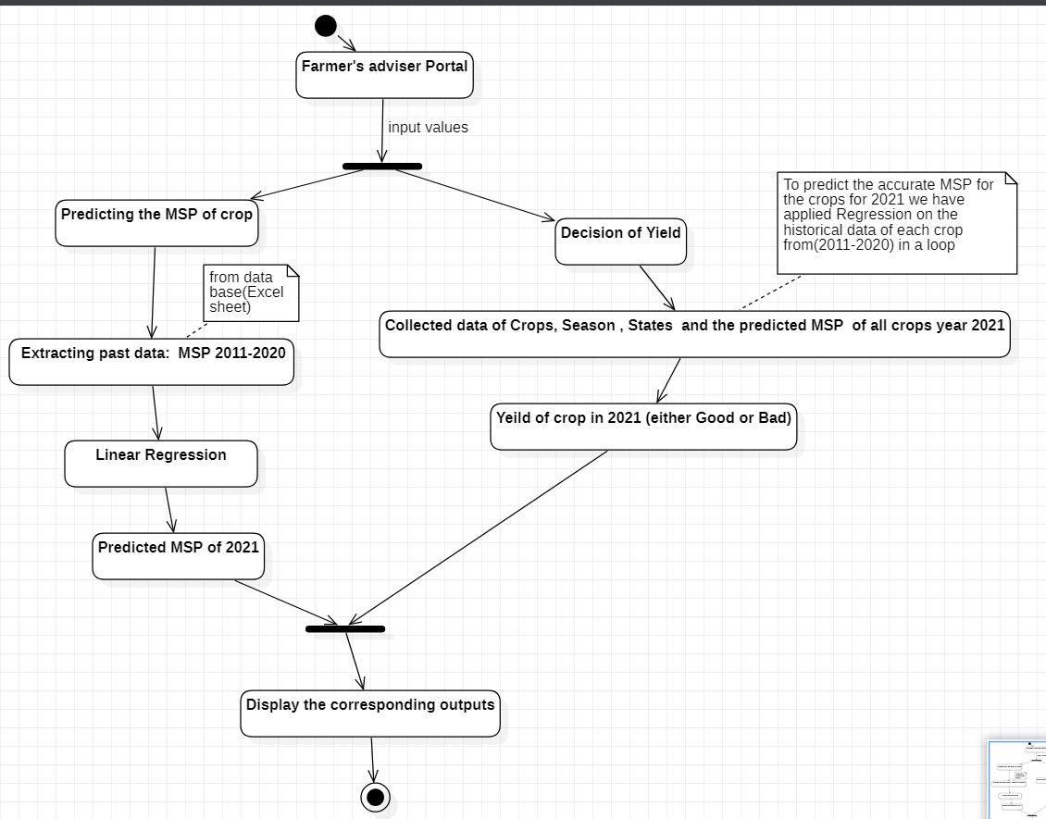

***Figure 1:*** Activity diagram of the project

# METHODOLOGY

* 1. Linear regression to find the MSP of the crops for year 2021. And decision tree to find the crop yield in terms of good and bad of all the crops.
* 2. Initially the data of MSP i.e. Minimum Support Price of crops and GDP (Gross Domestic Product) have been taken of past 10 years (2011-2020).
* 3. Now we will calculate the MSP of a particular crop for year 2021 and repeated the same for all the crops.
* 4. Secondly the past data of rainfall and temperature have been collected of 3 different states from 2011 to 2020 from the weather forecast of India. Hence, telling the farmers that which crop will suit your farm if your farm is located in Uttar Pradesh, Andhra Pradesh or Maharashtra.

5. Then the classification of crop yield of all the crops is done into 2 types- Good and bad by analysing.

* 6. Finally by using decision tree we got the yield type of particular crop for a given location and best season for its growth in 2021
* 7. Lastly, a front-end has been prepared which was named as Farmers Advisor.
* 8. And linked the outputs of both the algorithms, so that the data of MSP of suitable crops and its crop yield can be displayed on the online portal after farmer providing the inputs.

# ALGORITHMIC IMPLEMENTATION

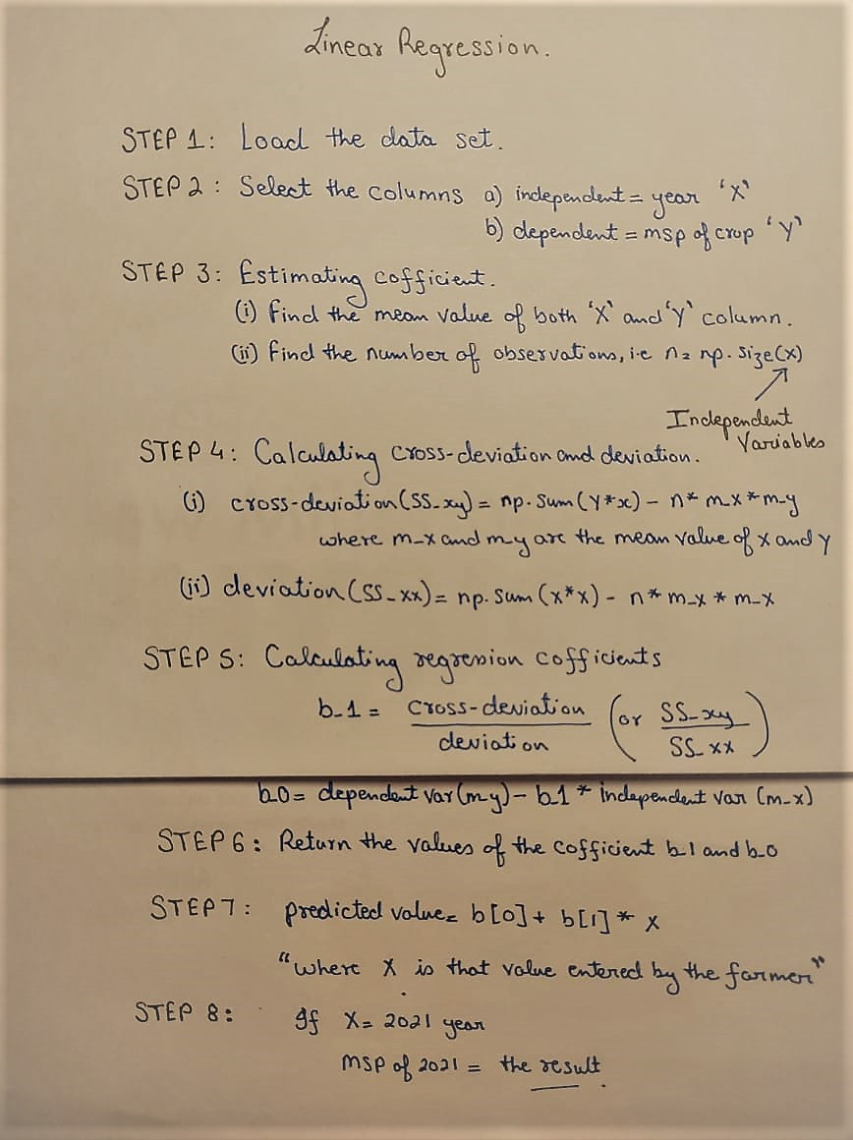

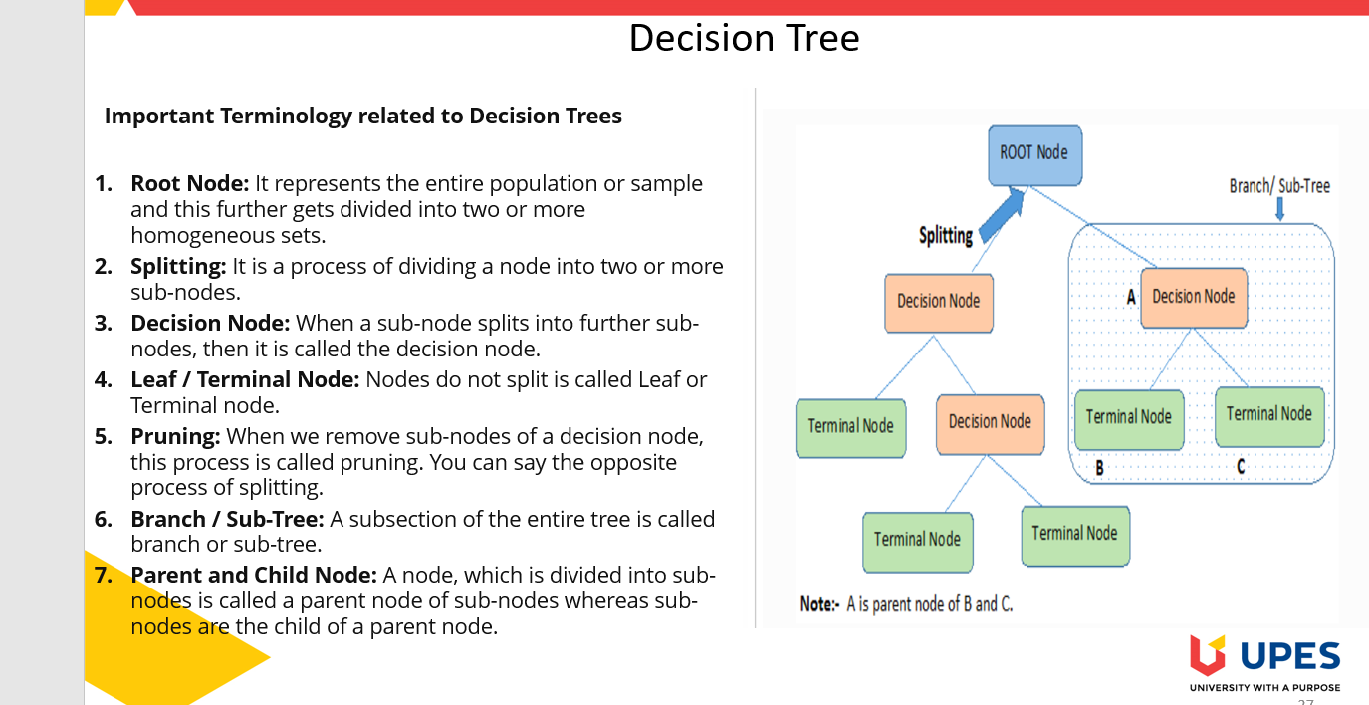

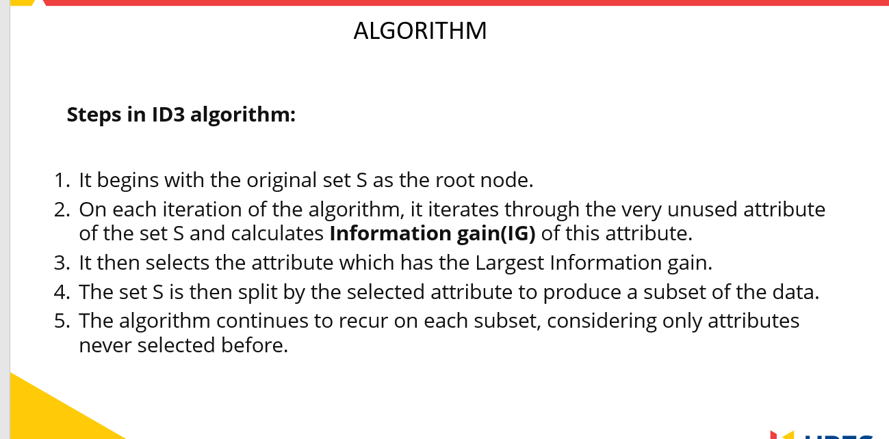

# REFERENCES

1. Geeks for geek data mining lesson in Association rule learning
2. Javatpoint learning python and Django frame work
3. http://www.vucreations.com/

[4] https://farmer.gov.in/mspstatements.aspx